**Assignment:**

You have to create a pipeline job, you have to install httpd server and deploy index.html page on httpd, using Jenkins and website should be up after job build.

Step 1: Launched an ec2 Jenkins Master with java, Apache tomcat and Jenkins.war file.

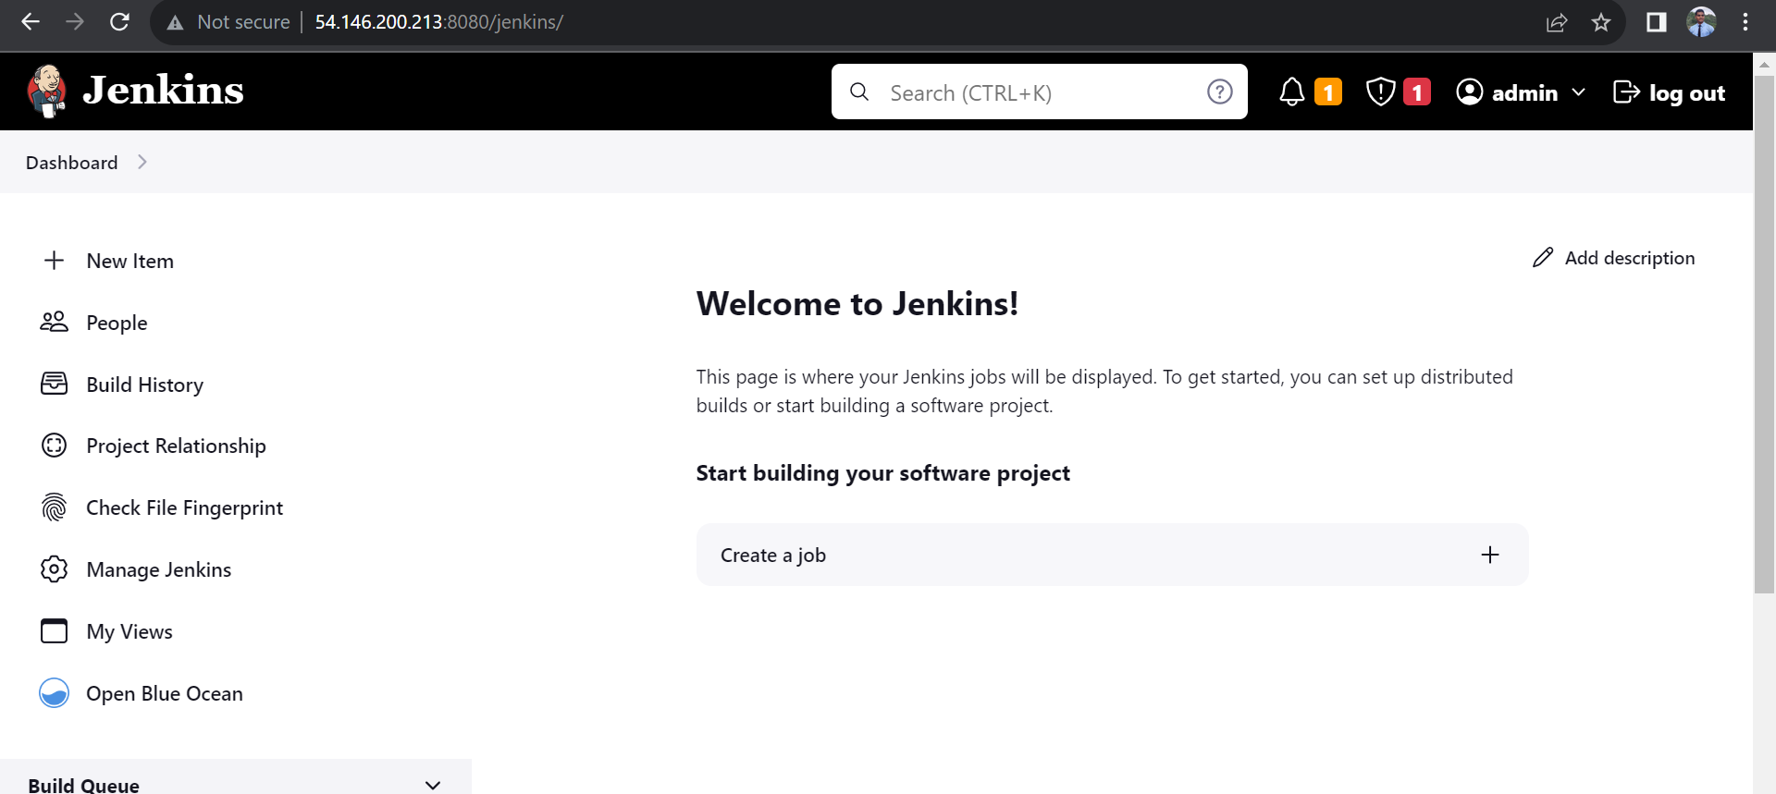

Step 2: Created index.html file on server at /mnt location

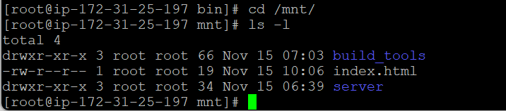

Step 3: Created a pipeline job in Jenkins

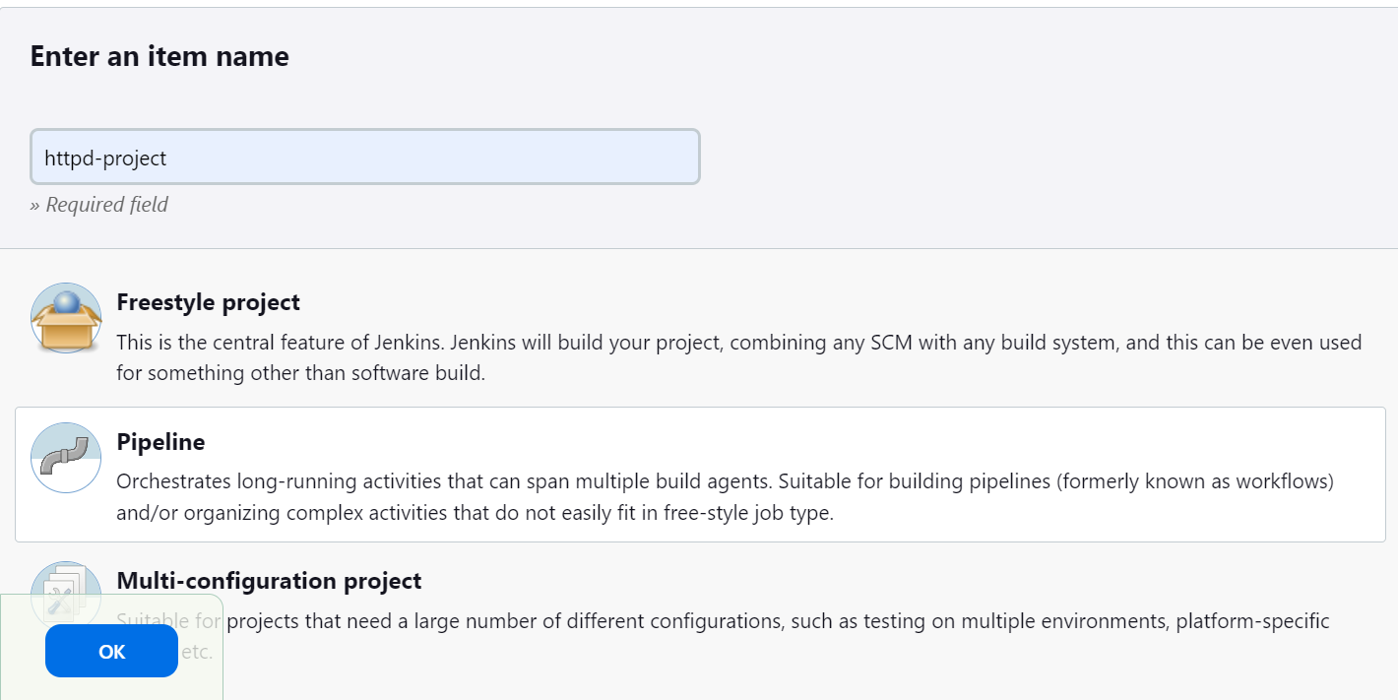

Step 4: Pipeline Script used:

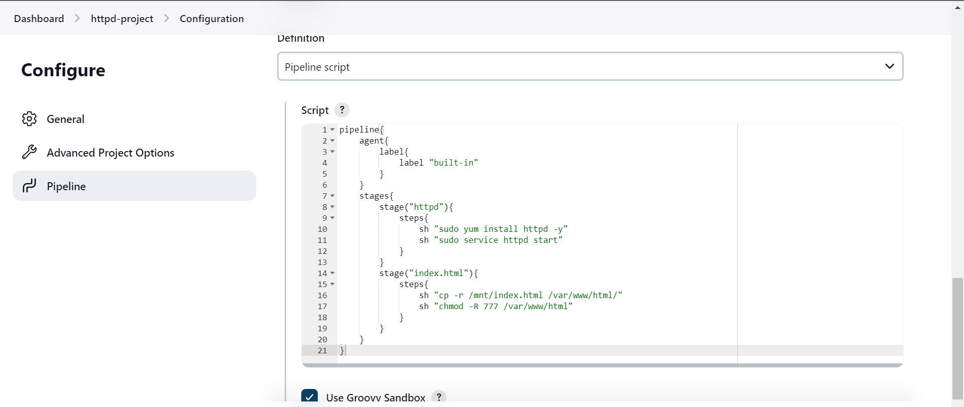

Successfully build the job.

